**Chinese Art of the Cultural Revolution**

Art of the Cultural Revolution includes large variety visual materials in different media created during the ten-year period, 1967-1977, of the Cultural Revolution in China. Generally characterised by unambiguous and heroic images appealing to the masses, these artworks became powerful tools of political propaganda. Most scholars attribute the beginning of the Cultural Revolution to the 1965 play *Hai Rui Dismissed from Office*. Written by a local Communist official, it was a thinly veiled critique of Mao Zedong. Though semi-retired in the early 1960s, Mao was determined to hold onto power by launching a new revolution to “reawaken” young Chinese people and to root out the “counterrevolutionary” and “anti-proletarian” elements in society. Under Mao’s directive, things, places, and people representing the Four Olds (Old Customs, Old Culture, Old Habits, and Old Ideas) were physically targeted and violently attacked by young people wearing red armbands and carrying the *Little Red Book* (a collection of quotes by Mao). Party officials, teachers, professors, authors, and artists had their homes raided and were publically dragged out by these so-called Red Guards for public humiliation; historical and cultural sites were desecrated and vandalised. While the real violence only lasted the first few years in the beginning, it set the tone of militarism and revolutionary fervor for the next decade, permeating through all the arts.

**The Visual Arts**

The visual culture of this period is characterised by a cacophonous yet aesthetically repetitive public display, best exemplified by the Big Character Posters. Layered on the facades of many public buildings, these large posters were filled with slogans taken directly from the *Little Red Book*.

Vying for wall space with the Big Character Posters were large graphic posters; these colorful posters also found their way into peoples’ homes next to portraits of Mao. Clear, strong, and bold graphics delineated the good from the bad, and the heroes from the villains; they would often serve as useful indicators for who or what was in and out of political favor in the Party. The accompanied text found on most posters ensured the “correct” political reading of these images, leaving little room for ambiguities. The overwhelmingly dominant color was red - the color of revolution and the Communist Party. Images of Mao and his symbolic representations (e.g. the sun, mangos, etc.) were the most central and much repeated subjects of these posters.

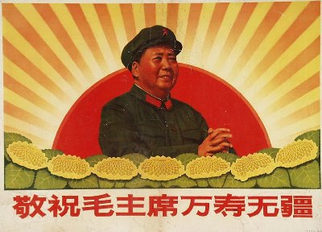

*Respectfully Wish Chairman Mao Eternal Life!,* 1968. Poster.

<http://iws.punahou.edu/user/cshigemitsu/worldlit/dialogues/2/images/mzd04.jpg>

Iconic images of Mao or heroes like Lei Feng were ubiquitous and repeated over and over again. For example, reproductions of the oil painting *Chairman Mao goes to Anyuan* (1968) by Liu Chunhua reached every commune in China. When it arrived at a commune, it was treated in the same way as a religious icon, being greeted and paraded by a large adoring crowd. This painting depicts an episode in early Communist mythology, when a youthful Mao traveled to the district of Anyuan to lead a miners’ strike. Having just reached the summit of a mountain, the young Mao radiates hope and revolutionary idealism. Like other posters from the period, the painting style was indebted to Soviet Social Realism and characterised by an uplifting and triumphal tone.

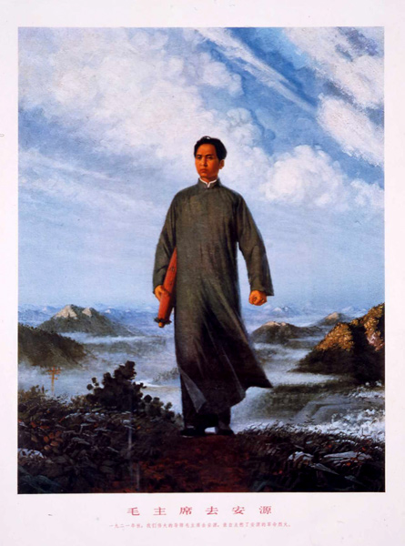

Liu Chunhua (1944 - ), *Chairman Mao Goes to Anyuan*, 1969. Poster.

http://sites.asiasociety.org/chinarevo/wp-content/themes/asoc/images/mao_02b.jpg

Instead of a singular author, most of the posters were made by groups of Propaganda Workers, young people who were part of a commune designing and executing the works together. More sophisticated posters were made on a large scale at the municipal or provincial level and distributed throughout China and the world.

While visions of the revolutionary heroic dominated, representations of class struggles persisted; the most famous was the clay sculpture group known as the *Rent Collection Courtyard*, permanently displayed in the former home of a landlord in Sichuan. Set up as a life-size diorama, it dramatically narrates the suffering of pre-revolution peasants at the hands of the ruthless landlords and their eventual liberation by the People’s Liberation Army. Created by Ye Yushan and a team of sculptors from Sichuan Academy of Fine Arts in 1965, copies were made and displayed in Beijing. It inspired similar didactic projects such as the *Wrath of the Serfs* (1976) at Tibet Museum.

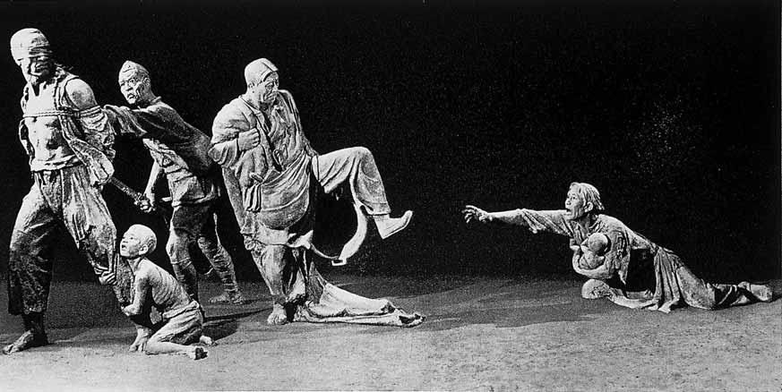

Ye Yushan and students from Sichuan Academy of Fine Arts, *Rent Collection Courtyard* (detail), 1965.

http://classconnection.s3.amazonaws.com/545/flashcards/2147545/jpg/chapter101354169546822.jpg

**Jiang Qing and Model Operas**

The explicitly stated goal for the sculptural dioramas was education, to become a model for future Chinese revolutionaries. These real-life and fictional models also existed in other forms, especially in the Eight Model Operas, which were the source for many of the themes and pictorial motifs in the visual arts of the period.

The Eight Model Operas includes two ballets: *The Legend of the Red Lantern (Hongdeng ji),* and *Shajiabang*. *Taking Tiger Mountain by Strategy (Zhiqu weihu shan), Raid on the White Tiger Regiment (Qixi baihu tuan), Ode of the Dragon River (Longjiang song), On the Dock (Haigang), The White-Haired Girl (Baimao nü),* and *Red Detachment of Women (Hongse niangzi jun)*, were all promoted and approved by Mao’s wife Jiang Qing, who had absolute control in all aspects of the arts. Similar to the *Rent Collection Courtyard*, the plot of many of “revolutionary” and “modern” operas (unlike the traditional Beijing operas) was about the struggles of proletarian heroes against the bourgeoisie and landlords, eventually leading to their final liberation at the hands of the People Liberation Army and the Communist Party. These operas travelled and were performed in every corner of China where they were often the only source of entertainment. The operas were remade into films, comic books, and concert pieces. Motifs from the operas were printed on posters, everyday objects, and textiles.

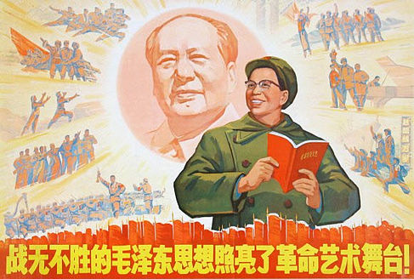

*The Invincible Thought of Mao Zedong Illuminates the Stage of Revolutionary Art!, 1969*. Poster showing Jiang Qing holding the Little Red Book, and vignettes of Jiang’s approved model performing arts radiating from the head of Mao as the sun.

http://upload.wikimedia.org/wikipedia/en/5/59/Jiang_Qing_arts_poster.jpg

The aesthetics of the Cultural Revolution have recently become popular again in the work of Chinese artists who have borrowed and appropriated themes and motifs from the period with a mixture of sarcasm and nostalgia. Camp and kitsch, these works were fitting tributes to loud, mass-produced, and politically driven propaganda. For example, Wang Guanyi’s early works deployed the brazen gestures and bold colors of the Cultural Revolution posters in the service of updated messages: capitalist consumerism of Western brands infiltrating China during the 1990s and 2000s.

**References and further reading:**

Cushing, Lincoln, and Tompkins, Ann (2007) *Chinese Posters: Art from the Great Proletarian Cultural Revolution*. San Francisco: Chronicle Books.

King, Richard, ed. (2010) *Art in Turmoil: The Chinese Cultural Revolution, 1966-76*.

Vancouver: University of British Columbia Press.

Murck, Alfreda. (2007) “Golden Mangoes – The Life Cycle of a Cultural Revolution Symbol.” *Archives of Asian Art*, 57: 1-21.

Chiu, Melissa, and Zheng, Shengtian (2008) *Art and China’s Revolution* (Asia Society). New Haven: Yale University Press.